A Week of Fish Vet Fun!
The ZEW Club and the Wildlife Disease Association student chapter are pleased to host Dr. Loh next week for some fascinating guest lectures!
Speaker: Dr Richmond Loh is one of the very few fish vets in Australia, as well as being a pathologist. (http://www.thefishvet.com.au/)
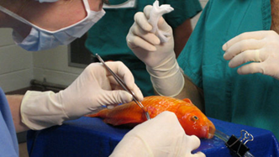
Lectures Scheduled:
Tuesday 22 July 2014: Practical Aspects of being a Fish Vet
Location: CR 1, Time: 12pm-1pm

Wednesday 23 July 2014: What does an Aquatic Veterinarian Do? We are more than just drug dealers
Location: CR 2, Time: 12pm-1pm

Thursday 24 July 2014: Getting Your Feet Wet- guidance and resources for developing aquatic veterinarians
Location: Lower Auditorium, Time: 12pm- 1pm

