REGISTRATION FORM

Please register by Mon 01 July 2013, the following people for the Workshop:

Name & Organisation | E-mail | Special dietary requirements, if any
Please indicate if you need a campus day parking permit for the 3 days. No. required: ________

Payment details: Registration fee is AUD$770 per person (inclusive of GST). Please provide current contact details. Send a crossed cheque made out to Murdoch University, addressed to 90 South Street, Murdoch WA 6150, or email credit card details to Dr. Susan Kueh, Email: S.Kueh@murdoch.edu.au
□Cheque (Cheques should be made payable to Murdoch University)
_____________________________________________________________________________
Or charge my credit card □Mastercard □Visa Amount : $________________

Card Holders Name:_______________________________________________________

Card No.:

Card expiry Date: / Signature:__________________

Murdoch Office Use Only: ACCOUNT CODE: 01-00-00-0710-5-15759-09817

Fish Pathology Workshop
Murdoch University, Perth on 22-24 Aug 2013 (Thurs-Sat)

Program for Day 1 – Thurs 22 Aug 2013
8.45 – 9.00 | Course Registration  Microscope suite VBSEC3.107 in Veterinary Biology Building
9.00 – 9.45 | Tutorial 1.1: Overview of workshop & Introduction to fish disease investigations (VBSEC3.107)  - Fish disease investigations  - Ubiquitous vs pathogenic organisms  - Basic epidemiology, disease dynamics & pathogenesis  - Basic water quality & fish physiology  - Normal fish histology
9.45 – 10.30 | Practical glass slide session 1.1 (VBSEC3.107)  - Normal Fish Histology
10.30 – 11.30 | Morning tea and coffee
11.30 – 13.30 | Practical glass slide session 1.2 (VBSEC3.107)  - Normal Fish Histology
13.30 – 14.30 | Lunch
14.30 – 15.15 | Tutorial 1.2: Viral diseases of fish (VBSEC3.107)  - Iridovirus  - Viral Nervous Necrosis  - Koi herpesvirus  - Others
15.15 – 16.00 | Practical glass slide session 1.3 (VBSEC3.107)  - Viral Diseases of Fish
16.00 – 16.30 | Afternoon tea
16.30 – 17.15 | Practical glass slide session 1.4 (VBSEC3.107)  - Viral Diseases of Fish
17.15 – 17.30 | Wrap-up session & discussions

Program for Day 2 – Fri 23 Aug 2013
8.45 – 9.00 | House-keeping session
9.00 – 9.45 | Tutorial 2.1: Bacterial Diseases of Fish (VBSEC3.107)  - Streptococcosis  - Tenacibaculosis/ Flavobacteriosis  - Vibriosis/ Aeromoniasis  - Mycobacteriosis & Others
9.45 – 10.30 | Practical glass slide session 2.1 (VBSEC3.107)  - Bacterial diseases of fish
10.30 – 11.30 | Morning tea and coffee
11.30 – 13.30 | Practical glass slide session 2.2 (VBSEC3.107)  - Bacterial diseases of fish
13.30 – 14.30 | Lunch
14.30 – 15.15 | Tutorial 2.2: Parasitic diseases of fish (VBSEC3.107)  - Protozoan  - Metazoan  - Direct vs indirect LC parasites & others
15.15 – 16.00 | Practical glass slide session 2.3 (VBSEC3.107)  - Parasitic diseases of fish
16.00 – 16.30 | Afternoon tea
16.30 – 17.15 | Practical glass slide session 2.4 (VBSEC3.107)  - Parasitic diseases of fish
17.15 – 17.30 | Wrap-up & discussion session

Program for Day 3 – Sat 24 Aug 2013
8.45 – 9.00 | House-keeping session
9.00 – 9.45 | Tutorial 3.1: Emerging & other significant diseases of fish (VBSEC3.107)  - Scale drop syndrome in Lates calcarifer  - Pot-belly disease in L. calcarifer  - Epiemeria in L. calcarifer  - Nutrtional myopathy  - Toxic gill changes
9.45 – 10.30 | Practical glass slide session 3.1 (VBSEC3.107)  - Emerging diseases of fish
10.30 – 11.30 | Morning tea and coffee
11.30 – 13.30 | Practical glass slide session 3.2 (VBSEC3.107)  - Other significant diseases of fish
13.30 – 14.30 | Lunch
14.30 – 15.15 | Tutorial 3.2: Investigating fish kills (VBSEC3.107)  - EUS  - Streptococcosis  - Oxygen depletion, toxic gases  - Toxic algae blooms  - Others
15.15 – 16.00 | Practical glass slide session 3.3 (VBSEC3.107)  - Miscellanous
16.00 – 16.30 | Afternoon tea
16.30 – 17.15 | Practical glass slide session 3.4 (VBSEC3.107)  - Miscellanous
17.15 – 17.30 | Wrap-up & discussion session

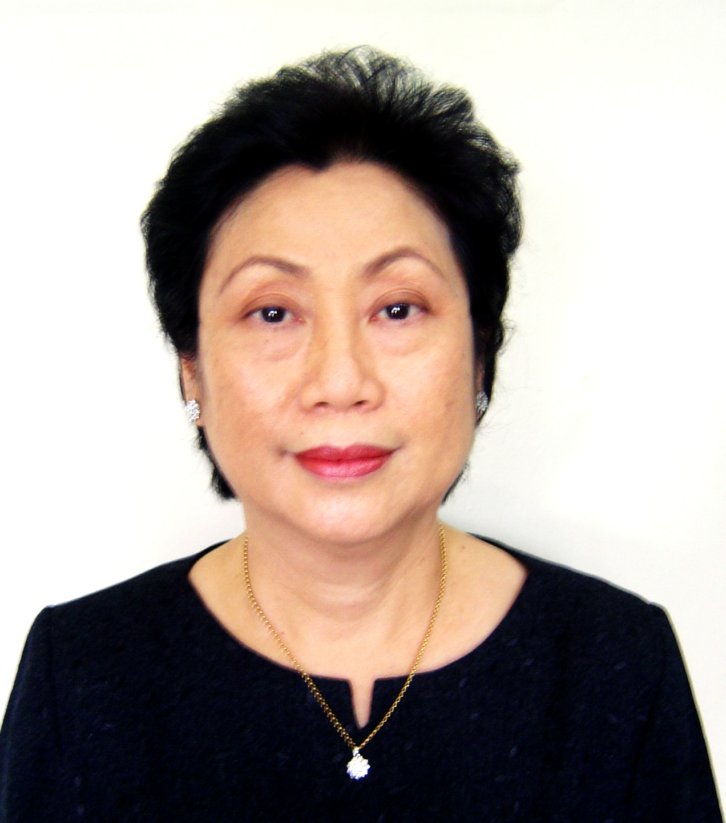

Dr. Supranee Chinabut (Presenter)

CV in brief: Dr Supranee Chinabut received her BSc from Fisheries Faculty, Kasetsart University, M.Sc. on Fisheries Parasitology from Auburn University and Ph.D. on Fish pathology from Stirling University in 1989. She has over 30 years of experience in research, disease diagnosis and teaching at both the national and international levels in aquatic animal health. Dr. Supranee has authored or co-authored more than 100 technical publications and 50 general fisheries articles between 1970 and 2005. She was the Chairperson of Fish Health Section/Asian Fisheries Society from 2001-2003. She is at present a Senior Advisor on Fish Diseases for the Department of Fisheries, Thailand and sits on the Advisory Group for NACA.

Contact details: Email: supraneecb@yahoo.com

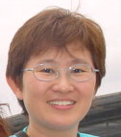

Dr. Susan Gibson-Kueh (Workshop Coordinator & Presenter)

CV in brief: Dr Susan Gibson-Kueh has a PhD in Fish Pathology from Murdoch University in 2013, an M.Sc in Aquatic Veterinary Studies from Institute of Aquaculture, University of Stirling, Scotland in 2001 and B.V.Sc from Sydney University in 1990. She currently teaches aquatic animal health and veterinary pathology at the School of Veterinary and Life Sciences, Murdoch University, and has 13 publications on fish diseases in peer reviewed international journals. Her research is focused on the pathogenesis, epidemiology and diagnosis of diseases in farmed fish.
As manager of the Aquatic Animal health Laboratory, AgriFood and Veterinary Authority of Singapore from 1995-2007, she was responsible for the quality assurance of the aquatic animal health laboratory under ISO17025 and disease diagnosis to support surveillance, disease control and health certification. She was national focal disease reporting person for aquatic animal diseases to NACA/OIE from 1995 – 2007.

Contact details: School of Veterinary and Life Sciences
Murdoch University, South Street,
Murdoch, WA 6150, Australia
Email: s.kueh@murdoch.edu.au

Location of the microscope suite VBSEC3.107 ( http://maps.murdoch.edu.au/ )

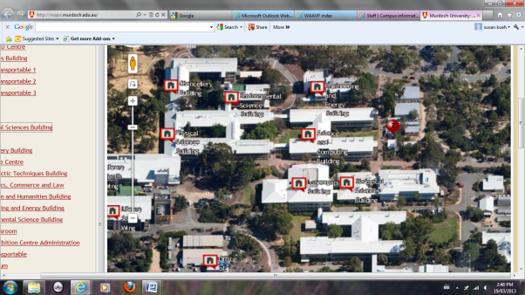
Microscope suite (VBSEC3.107)

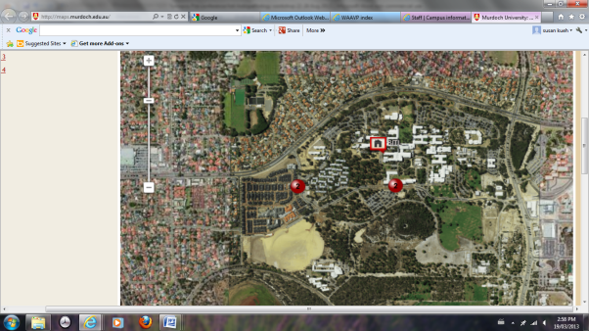
Bus stop
Vet hospital
Murdoch Dr
South St
Microscope suite VBSEC3.107
The nearest train station is MURDOCH Station. Buses connect Murdoch Station to the university. Please note that there is a new bus stop before the one indicated on map - just ask for the veterinary hospital.
Synopsis of workshop:

This 3-day workshop will be held at the teaching multi-header microscope suite (VBSEC3.107) at the Murdoch University School of Veterinary Science. The workshop is designed with the fish health diagnostician as well as researcher/ postgraduate student in mind. At the end of the workshop, participants will have developed some level of confidence in carrying out sound disease investigations in finfish, appreciate normal finfish histology as well as be able to recognize significant and emerging diseases of important cultured finfish species in Asia and Australia. The finfish species covered in this workshop will include both freshwater ornamental fish and marine food fish.

There would be opportunities to spend some time on histological glass slide materials that participants are encouraged to bring along to the workshop. Participants will receive a set of DVDs of selected virtual microscopy slides reviewed during the workshop, which will serve as invaluable resource reference materials. This workshop will be an exciting forum for you to review the histological materials of emerging and significant finfish diseases, materials brought along by your peers as well as your own materials. There will be ample opportunity to seek the opinions of presenters as well as other participants during the workshop.

Some participants are going onto attend the International Parasitology Conference that follows straight after, from Sun to Thurs 25-29 Aug. There will be a special aquatic session at this conference. They have listed some accommodation at the website. Please see http://www.waavp2013perth.com/index-waavp.html and http://www.waavp2013perth.com/waavp/accommodation.html

Please note that the parasitology conference will be held at the Perth Convention Centre in the city's CBD, but the fish pathology workshop will be held in the multiheader microscope suite at the veterinary school in Murdoch University, South Street campus – this is located 20-25 minutes by road or rail from the city. The university is connected by train from the city, so that accommodation in the city near to a train station will be convenient. The Murdoch train station is the nearest, and is connected by a short bus ride to the university. Another suitable option for accommodation is in Fremantle: Murdoch University is located about 15mins from Fremantle, which is a popular place to stay. There is limited accommodation on the campus itself during term time, but I can find out more if you would like some information. If you have trouble accessing website by clicking onto the link, please copy and paste onto a search engine such as google.
Other Information on the Fish Pathology Workshop 22-24 Aug 2013:
We are pleased to announce that Dr Supranee Chinabut, a veteran fish pathologist from Thailand will be co-presenting this workshop with Dr Susan Gibson-Kueh. Together, these two main presenters have a combined experience of over 50 years in fish diseases of relevance to Asian aquaculture. The detailed program is appended above.

We have a good collection of histology glass slide materials at Murdoch University:
- Cases from our work in Asia
- Materials sent to us from throughout Asia including Singapore, Malaysia, Indonesia, Vietnam and Australia
- Case materials from the Fish Health Laboratory, Fisheries Dept WA, who has kindly consented for them to be used at this workshop
- Reference slide materials from our Fish Pathology Master Class in Bangkok in 2007, kindly provided by some of the presenters as Prof. Barbara Nowak, University of Tasmania and Prof. Teruo Miyazaki, University of Mie, Japan.
- An internationally sourced and audited collection from the Joint Pathology Centre, formerly Armed Forces Institute of Pathology, USA.

In addition, we ask that you start thinking about some case materials you would like to review at this workshop – these glass slides can be sent ahead (if you wish) by air-mail to:
Dr Susan Gibson-Kueh
Dept. of Veterinary Pathology
School of Veterinary and Life Sciences
Murdoch University, South Street,
Murdoch, WA 6150, Australia

One of the key aspects of small group workshops such as this one in Perth in Aug, is the face-to-face interactions and resulting social and professional links that develop and then persist. Such workshops are so important for those working in isolation within their speciality, and more so if they are looking to consolidate and develop their skills, and to take what they have learned and share it with local and remote partners. What has been apparent from the previous Crawford/ACIAR funded aquatic health masterclass in Bangkok in 2007, is that participants have made useful links during the workshop, and then these have continued and flourished using Google Groups or other networking technologies afterwards.

This workshop will be the first when we will use internet delivery of virtual microscopy slides, using a Murdoch University online learning management platform (Moodle) that will allow participants both to access the educational material online afterwards, and perhaps share with colleagues, and to continue to share further new case material for discussion and education. The technology for large-file serving, as required for digital or virtual microscopy, has only recently matured, and is facilitated by our ability to digitally to extract key regions of interest from whole slide images, allowing high speed download of the smaller extracts. Also, we can attach educational labels and comments electronically to the images, which is important once face-to-face opportunities have finished.

We look forward to seeing you in Perth in Aug. Please do not hesitate to ask for clarifications if you have any further queries. And of course, we will welcome any suggestions for topics that will add to the learning experience at this workshop.

Susan

