FRDC Regional Workshops on Pathology of Aquatic Animals
Presented by Dr Teruo Miyazaki, Mie University, Japan,
At Murdoch University, Perth on Thurs 16 May 2013

Dr Teruo Miyazaki is Professor Emeritus in the Graduate School of Bioresources, Mie University, Japan. His extraordinary career spans 40 years of active engagement in aquatic animal health. He is the author of several textbooks including the highly regarded “Color Atlas of Fish Histopathology” (Vols 1 and 2) and numerous scientific papers.
Cost: $50 per participant ($25 per student)
Program
8.30 – 8.45 | Course Registration
8.45 – 9.00 | Welcome and introduction of Dr Miyazaki (chairperson) (Loneragan LT)
9.00 – 9.45 | Lecture 1: Chasing the true pathogen – investigating the aetiology of new and emerging diseases in finfish.(Loneragan LT)  - Re-emerging ulcer disease of koi  - Goldfish sleepy disease  - Koi sleepy disease
9.45 – 10.30 | Lecture 2: Disease investigations and pathology of shrimp and mollusks. (Loneragan LT)  - Pearl oyster mass mortality  - Taura syndrome of vannamei shrimp  - WSS in kuruma prawn
10.30 – 11.30 | Morning tea and coffee
11.30 – 13.30 | Practical glass slides session – conundrums. (Microscope suite VBSEC3.107)
13.30 – 14.30 | Lunch
14.30 – 15.15 | Lecture 3: Newly emerging and exotic diseases, highlighting the role of electron microscopy in the investigation of aquatic animal health, to reveal the nature of viruses. (VBS3.023)  - Alloherpesviruses  - IgY-immunizathion for Goldfish hematopoietic necrosis with CyHV-2  - Megalocytivirus disease
15.15 – 16.00 | Lecture 4: Newly emerging nutritional and metabolic disease of finfish. (VBS3.023)  - Methemoglobinemia  - Melamine-induced nephropathy  - Nutritional myopathy syndrome in cultured fishes
16.00 – 16.30 | Afternoon tea
16.30 – 17.15 | Lecture 5: Special topics – To be announced (VBS3.023)
17.15 – 17.30 | Closing comments (chairperson)

REGISTRATION FORM

Please register by: Friday 10 May 2013

Please complete this form and send to: Dr. Susan Kueh
Email: S.Kueh@murdoch.edu.au

Please register the following people for the Workshop:

Name | E-mail | Organisation
Payment: Note all fees are GST inclusive. Please provide all contact details. Send a crossed cheque made out to Murdoch University, addressed to 90 South Street, Murdoch WA 6150, or email credit card details to Dr. Susan Kueh
□Cheque (Cheques should be made payable to Murdoch University)
Or charge my credit card □Mastercard □Visa Amount : $__________

Card Holders Name:______________________________

Card Number: 

Card expiry Date: / Signature:__________________

Murdoch Office Use Only: ACCOUNT CODE: _____________________

2012-2013 FRDC Visiting Expert Bursary – Prof. Eimeritus Teruo Miyazaki, a background on visit
This visit forms part of an Australia wide tour by Prof. Miyazaki under the ‘People development program: Aquatic animal health training scheme’ and is funded by the FRDC on behalf of the Australian Government.
Improving aquatic animal health diagnostic capacity is a priority for FRDC specifically to prevent and manage disease incursions, and to develop diagnostic procedures and techniques to rapidly detect and identify pathogens. This is also a priority for state jurisdictions.
Viral diseases are among the most important of all health issues in aquaculture and fisheries. Their rapid and accurate recognition is central to the prevention of spread and the control of emerging diseases. Morphological diagnosis based on gross pathology, histopathology and electron microscopy is vital in the diagnostic process, and is essential to complement accurate molecular aetiolgical diagnosis. However, practitioners of morphological diagnosis are becoming scarce.
The FRDC Visiting Expert Bursary awarded to Dr Teruo Miyazaki from Japan enables knowledge transfer from one of the world's foremost experts, in a small group setting, with plenty of opportunity for discussion. In addition to viral diseases, Dr Miyazaki has career long expertise in general fish pathology, so his visit presents diverse opportunities for continuing education of Australian aquatic animal health diagnosticians. Molluscs and crustaceans will also be covered at the workshops.
Beneficiaries include aquatic animal health diagnostic laboratories throughout Australia and the potential impact is enhanced diagnostic capacity, enabling more rapid and accurate diagnosis of finfish diseases, which facilitates disease prevention and control, and greater industry awareness of aquatic animal health. The visit provides a unique opportunity for exchange of technical information pertaining to the diagnosis of internationally significant diseases of aquatic animals, and for specific instruction of Australian laboratory diagnosticians.
Dr Teruo Miyazaki is Professor Emeritus in the Graduate School of Bioresources, Mie University, Japan. He has an extraordinary career history spanning 40 years of active engagement in aquatic animal health. He is the author of several textbooks including the highly regarded “Color Atlas of Fish Histopathology” (Vols 1 and 2) and numerous scientific papers.

Professor Teruo Miyazaki

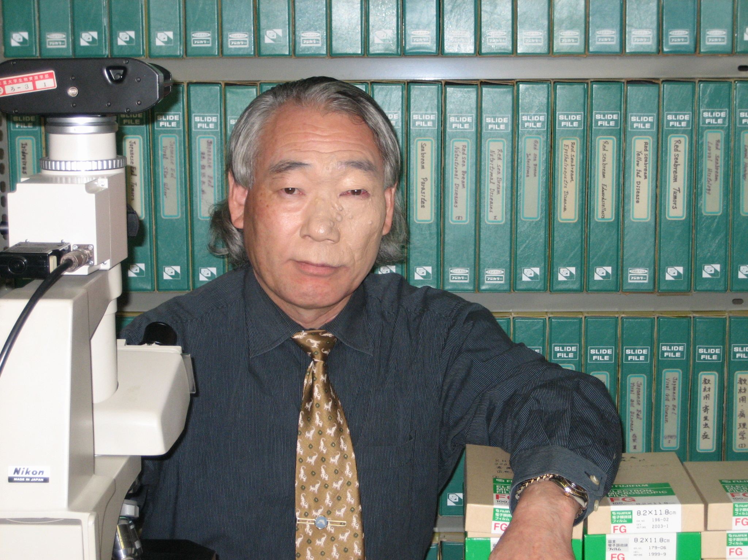

Teruo Miyazaki is Professor Emeritus at the Graduate School of Bioresources, Mie University since 2012. From 1973 to 1975 he was Assistant Professor at the Faculty of Fisheries, Mie Prefectural University, from 1975 to 1984 Assistant Professor at the Faculty of Fisheries, Mie University, from 1984 to 1987 Associate Professor in the Faculty of Fisheries, Mie University, and from 1987 to 1994 Associate Professor in the Faculty of Bioresources, Mie University. He gained a Bachelor of Fisheries (1971) in Mie Prefectural University, a Master of Agriculture (1973) in the University of Tokyo, and a Ph. D. (1979) also in the University of Tokyo.

His research is focused on histopathological features of major bacterial, fungal, parasitic, nutritional and viral diseases of cultured marine and freshwater fishes. His work has also involved demonstrating the ultrastructural features of major viral diseases by TEM. He has published over 100 papers in international journals and two books entitled “ Color Atlas of Fish Histopathology; Volumes 1 & 2”. He is also involved in supervision of many Japanese and foreign students for doctorate and master degrees.

Contact details: Graduate School of Bioresources
Mie University
1577 Kurima-maciya-cho, Tsu
Mie 514-8507, Japan
Email: miyazaki@bio.mie-u.ac.jp

